***Term project report***

***Problem statement:***

All tourism packages will be available will be available to the user to choose from. Once a user is settled down with a trip package, a summary of the tour with cost breakdown will be displayed to the user.

***Introduction:***

When the program is started, the user is displayed with a list of options from the text file using file handling. From the menu displayed, the user will pick a tour package and then enter the required details like name, age, CNIC, current address. The personal information of the user will be stored in another file using file handling so that it remains saved in the data base. Multiple users’ data can be stored in the file in this way. After that the user will be asked some information required to make their tour according to their requirements. That data includes no of people going on the tour, meals that will be given on the tour, to ask the costumer whether they want to hire a tour guide a tour guide for the tour or not. The next thing the user will be asked about will be that whether they want to have a private trip, which will cost extra charges, or they can go with another family and share the expenses.

***Class diagram:***

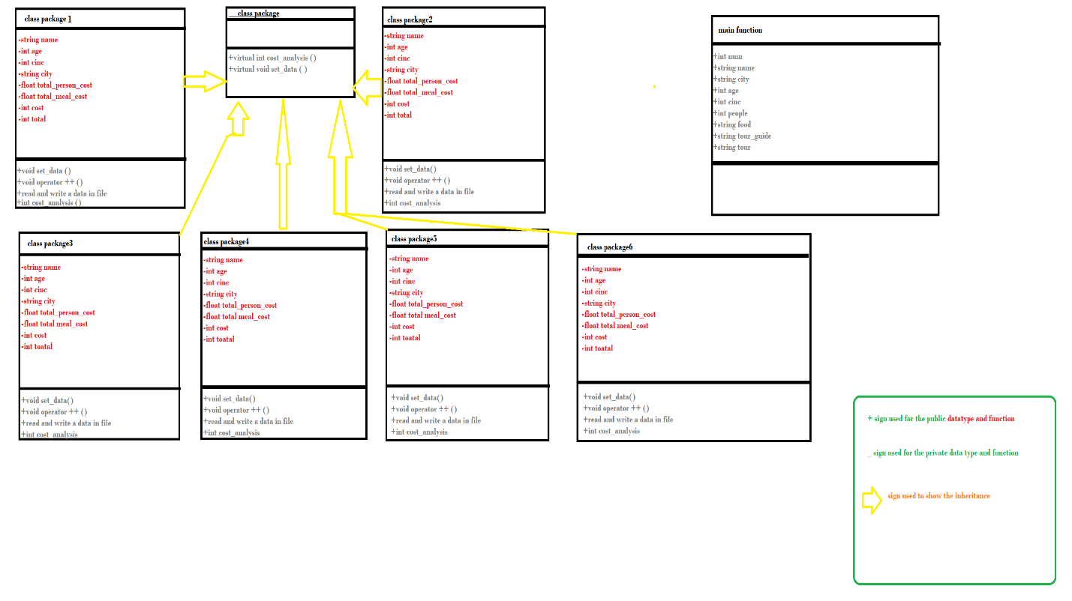

***Functional requirements:***

The key requirements for this project are:

* Classes with inheritance (relations).
* Use of virtual functions (polymorphism).
* Operator overloading to make a function work differently.
* File handling to read the tour packages and then store the personal data of the user in the database.
* Exception handling for pointing out errors and taking suitable measures like asking the user to enter the choice again with correct format.
* Use of standard template library for making our code generic and user friendly.

***C++ Code description:***

First of all, when you start the program, a menu will appear that is displayed from a text file using file handling. From that menu user is prompt to choose an option of tour package that they want to go on to. After that the user will be prompt to enter their personal data such as first name, age, CNIC, current address etc. After that the data entered by the user is sent into a newly opened text file called costumer data where multiple user’s data can be stored. Then the user is prompt to enter the details of the tour. These details include no of people going on the tour, meals availability, tour guide hiring preference, and asking them if they want to go on the tour privately or with another family as it will be cheaper than the other. Then we are going to check the provided details validity using multiple if-else conditional statements. In this we are also going to calculate the total and distributive cost of the tour package in the cost_analysis function. There are 5 packages so far and therefore there are separate classes for the packages with separate cost calculating functions. After that the user is shown how much is the total cost of the trip is with their entered specifications. Then the user is asked whether they want to book another tour. If they press yes then the look will continue and the whole sequence will happen again but if they press no then the program will end.

Given below is the picture of the program’s menu screen.

